Q1)

print("sequence numbers from 20 to 50: ")

print(seq(20,50))

print("mean of no. from 20 to 60: ")

print(mean(20:60))

print("sum of numbers from 51 to 91")

print(sum(51:91))

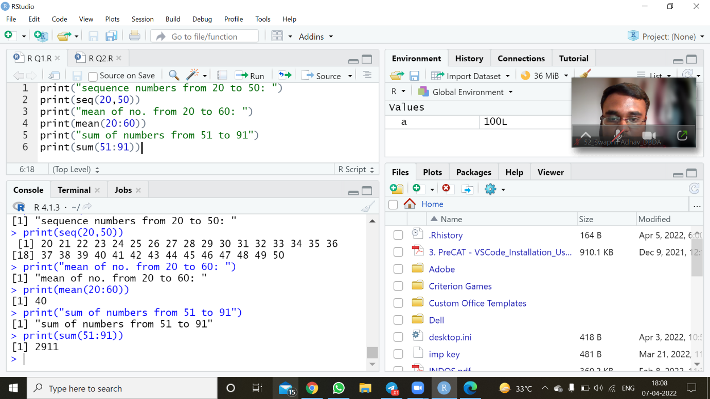

Q2)

for (a in 1:100) {

if (a %% 3 == 0 & a %% 5 == 0) {print("FizzBuzz")}

else if (a %% 3 == 0) {print("Fizz")}

else if (a %% 5 == 0) {print("Buzz")}

else print(a)

}

